**Guide to install Ubuntu on VirtualBox**

**1. Downloading Essentials:**

a) VirtualBox:

1. Visit <https://www.virtualbox.org/wiki/Downloads> .

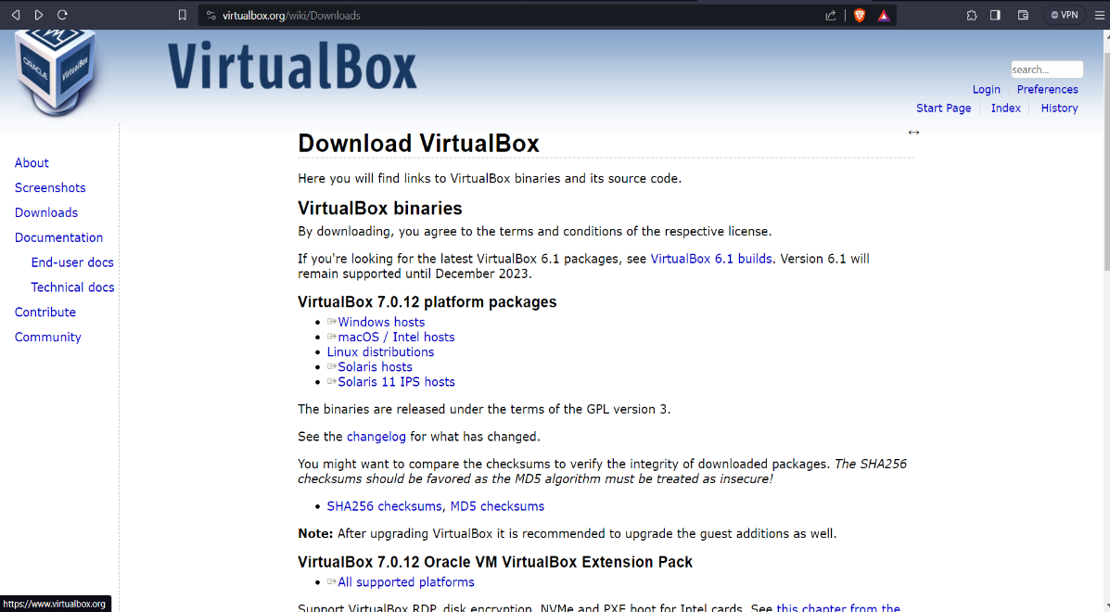

1. Choose your operating system from the menu.
2. Follow the on-screen instructions to install VirtualBox.

b) Ubuntu ISO:

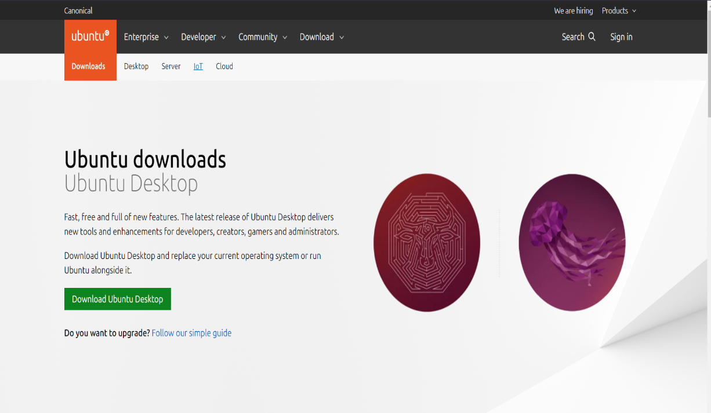

1. Go to <https://ubuntu.com/download>.
2. Choose the desired Ubuntu version (e.g., 22.04 LTS).
3. Click "Download" and select either "Download with Torrent" or "Direct Download".
4. Save the ISO file to a convenient location on your computer.

**2. Creating the Virtual Machine:**

1. Open VirtualBox.

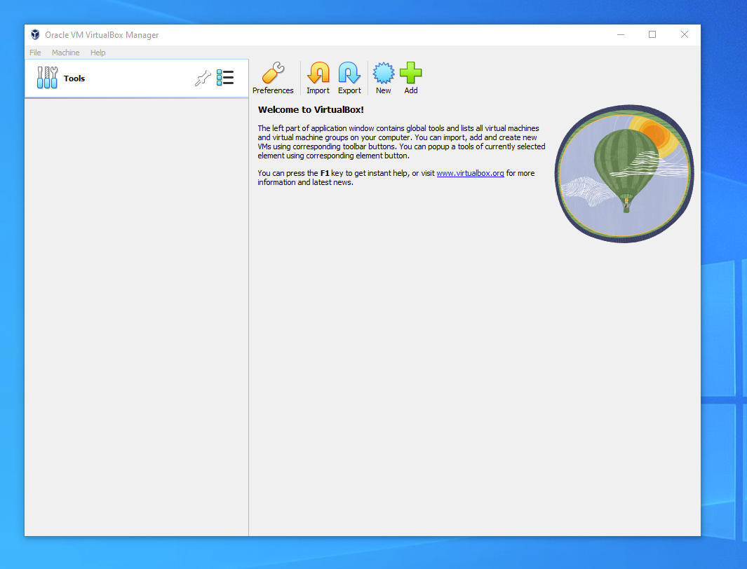

1. Click the "New" button to create a new virtual machine.
2. In the "Create virtual machine" window:
   * Name: If you include the word Ubuntu in your name the Type and Version will auto-update.
   * Machine Folder: This is where your virtual machines will be stored so you can resume working on them whenever you like.
   * ISO Image: Here you need to add a link to the ISO you downloaded from the Ubuntu website.
   * We want to install Ubuntu unattendedly so we can leave the checkbox to skip unchecked.

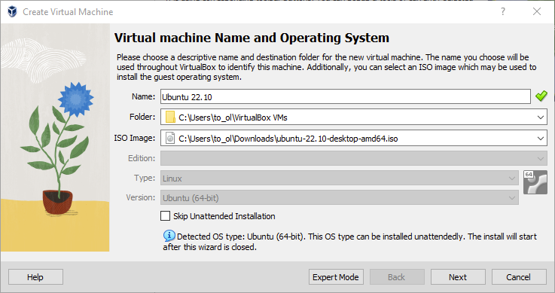

1. Click "Next".
2. Create a user profile

The default credentials are:

* Username: vboxuser
* Password: changeme

Note - It is important to **change these values** since the defaults will create a user without sudo access.

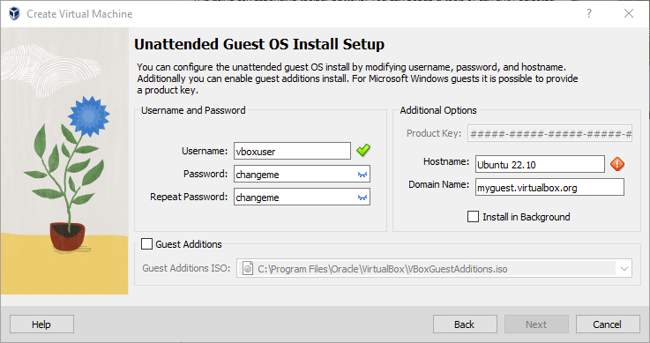

1. Define the Virtual Machine’s resources

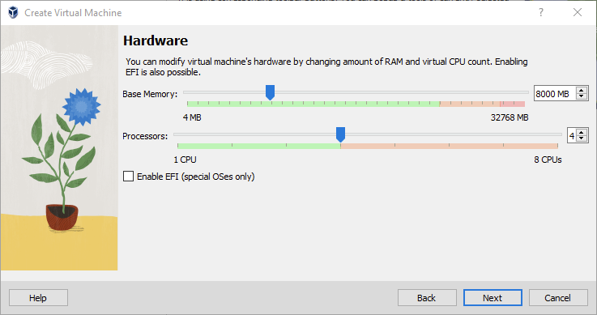

This section guides you through allocating resources for your virtual machine (VM). To ensure smooth performance, aim for:

* RAM: 8GB recommended (minimum 4GB)
* CPUs: 4 cores

Stick to the green areas on the sliders to avoid performance issues on both the VM and your host machine.

1. In the "Create virtual hard disk" window:

* Minimum recommended: 25GB for Ubuntu.
* Dynamic allocation: Size automatically expands as needed (default).
* Pre-allocation: Allocate the full size upfront (optional, improves performance but uses more space). Choose based on your needs and available disk space.

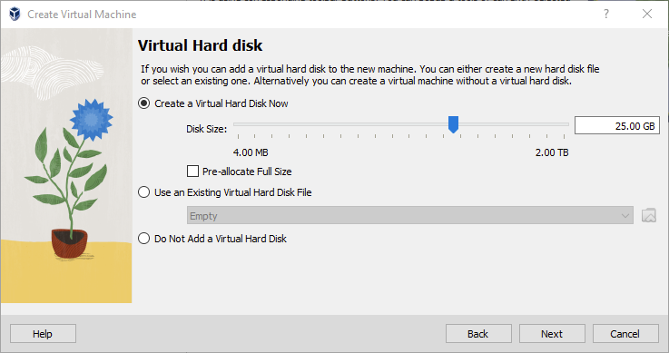

Click **Next** to continue and view a summary of your machine setting

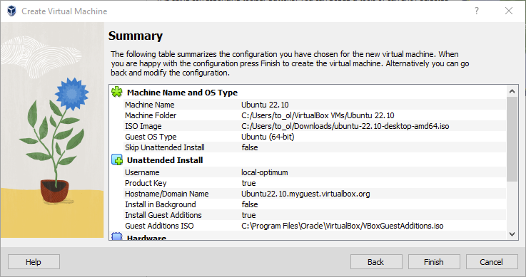

After this click **Finish** to initialize the machine!

**3. Starting the Installation:**

1. Select the newly created virtual machine in the VirtualBox main window.
2. Click "Start" to boot it up.
3. When prompted, click on the "CD/DVD icon" and choose "Open virtual optical disk...".
4. Select the downloaded Ubuntu ISO file and click "Open".
5. The Ubuntu installation process will begin. Follow the on-screen prompts:
   * Choose your preferred language.
   * Click "Install Ubuntu".

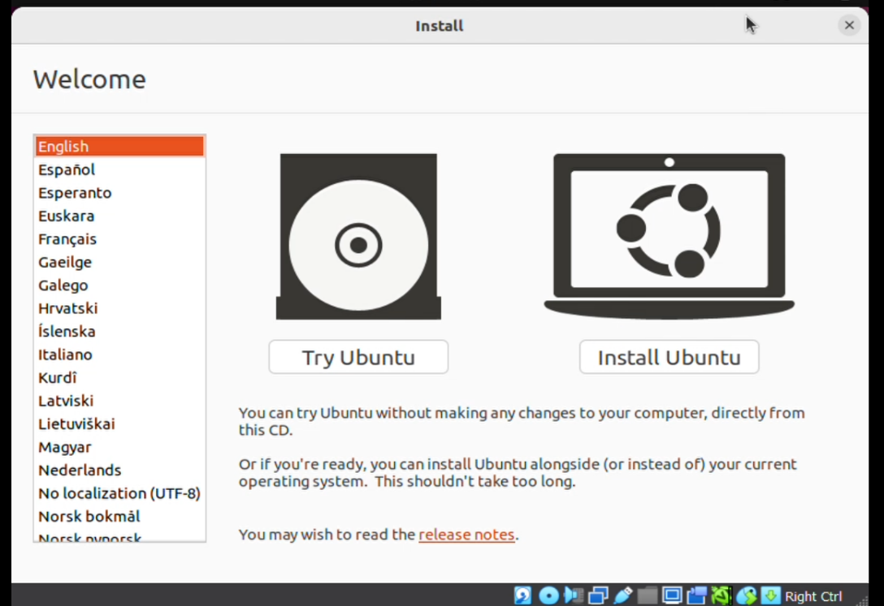

* + Choose your keyboard layout.

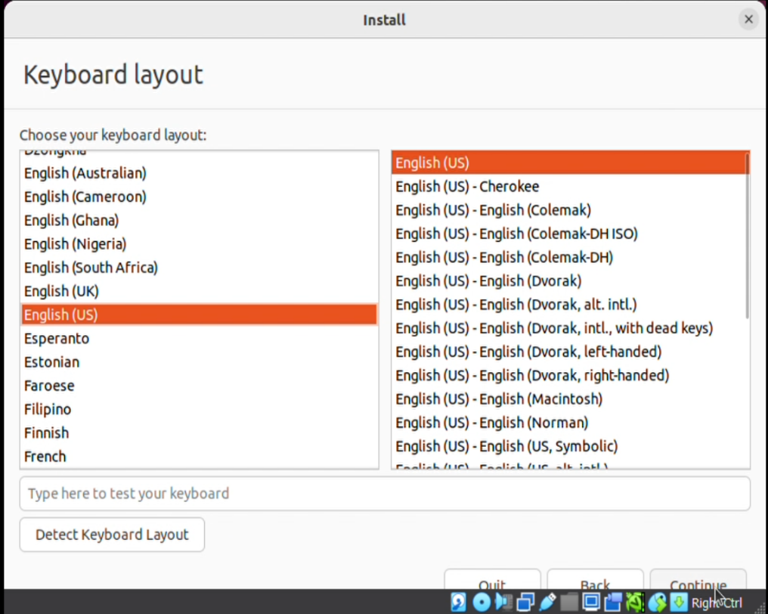

* + Select Normal installation.

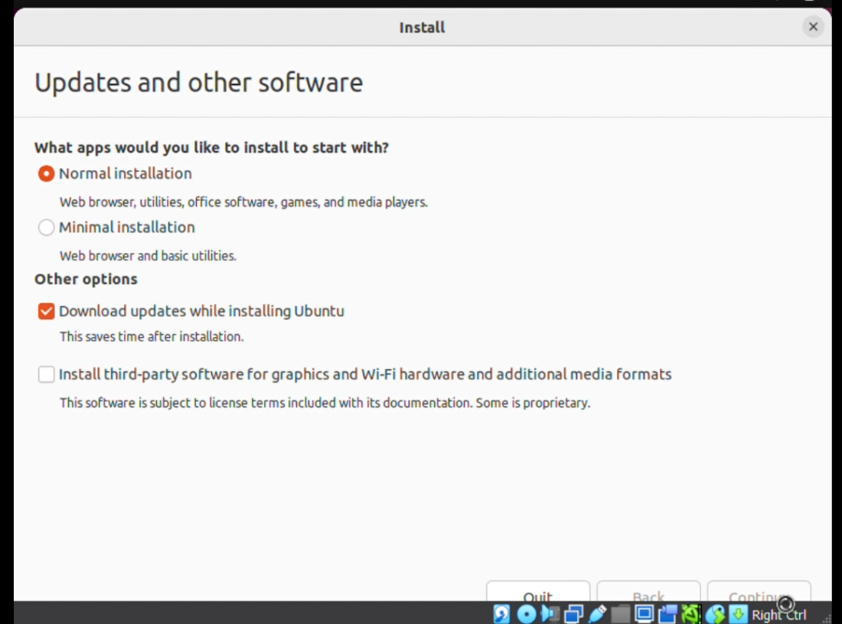

* + Choose "Erase disk and install Ubuntu" for a fresh installation (warning: this will erase all data on the virtual hard disk).

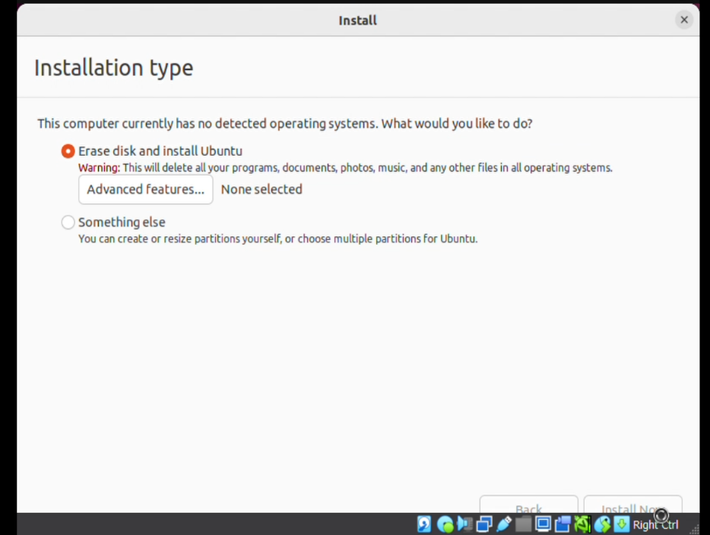

* + Set your geographical location.

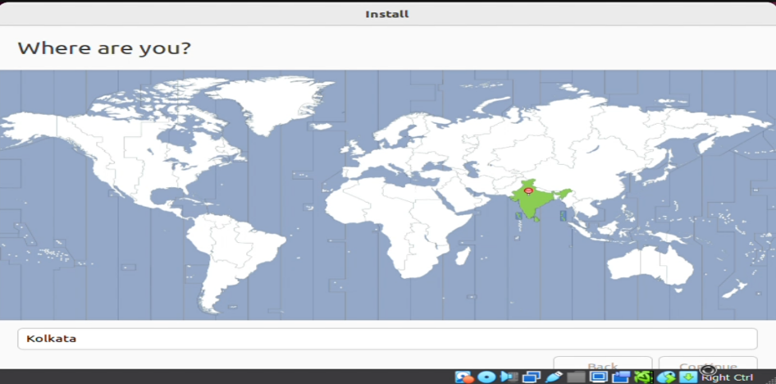

* + Create a username and password for your Ubuntu account.

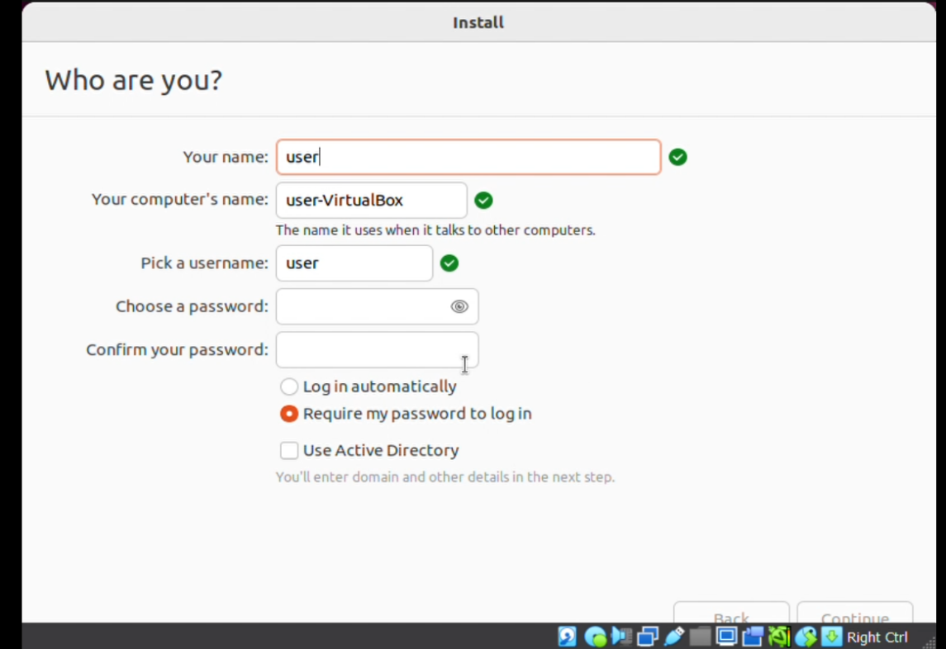

**4. Completing the Installation:**

1. Wait for the installation to complete (it might take some time).

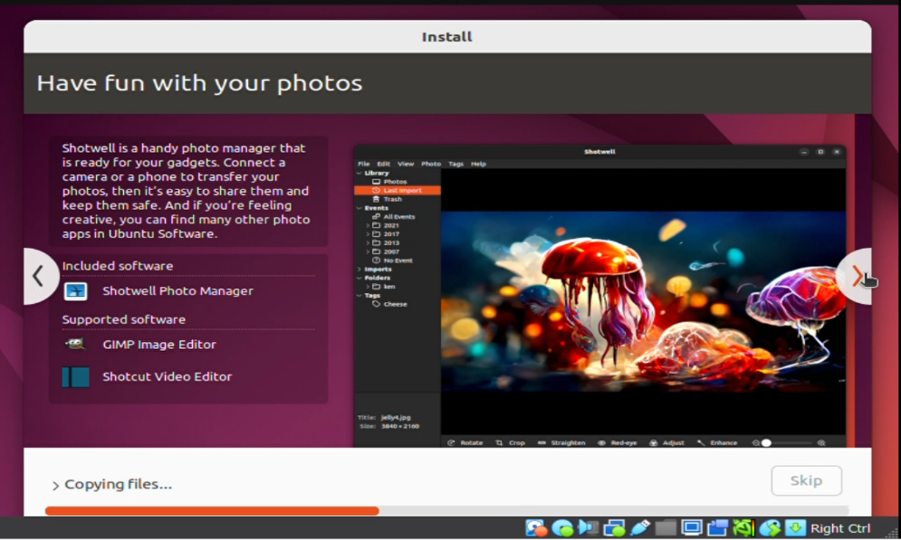

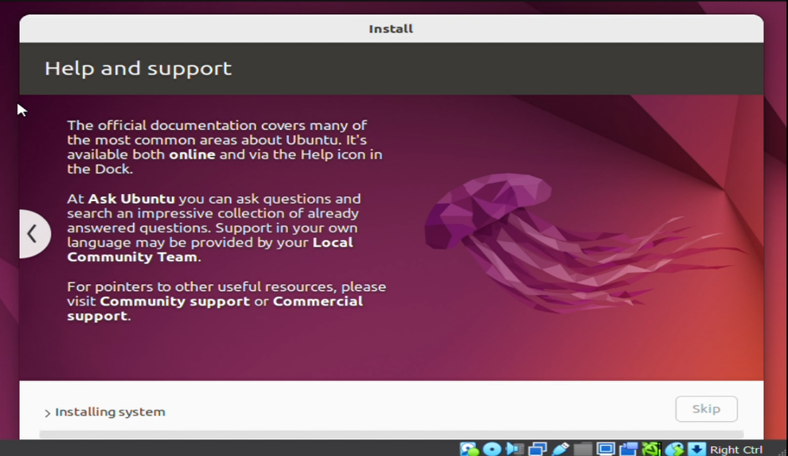

1. When prompted, press Enter to remove the Ubuntu ISO file.
2. Click "Restart Now" to finish the installation.

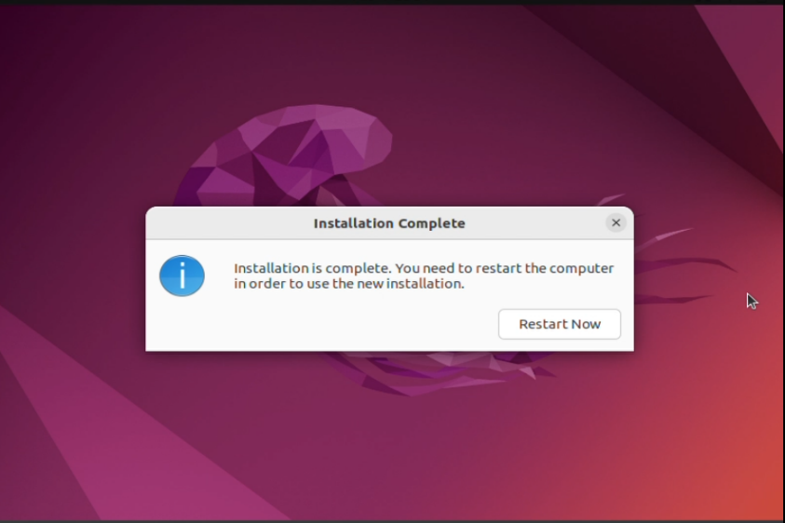

1. After the reboot, you'll be prompted to log in using the username and password you created earlier.

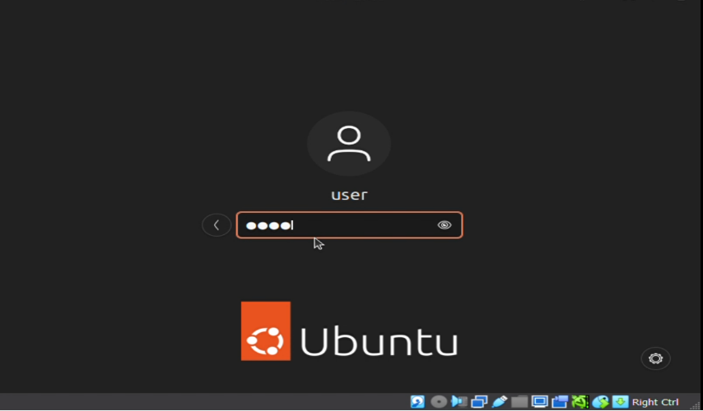

1. Congratulations! You've successfully installed Ubuntu on VirtualBox!

